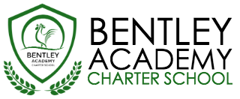
Bentley Academy Charter School
Board of Trustees Meeting
Wednesday, July 26, 2017
5:30pm
At the Salem Inn
7 Summer Street, Salem MA 01970

Mission: Bentley Academy Charter School prepares all of its students for personal and academic success to get to and through college. Through a combination of high academic standards, data-derived instructional methods, and community supports and partnerships, Bentley Academy Charter School establishes the critical foundation necessary for students to thrive as they advance in their academic careers.

5:30 | - Call to Order
5:65-5:40 | - Approval of Minutes (Action Required)
5:40-5:50 | - Head of School Update and Academic Update
5:50-6:00 | - Accountability Plan (action required)
6:00-7:45 | - Strategic Planning  - Special guest: John Tarvin, Claremont Consulting
8:00 | - Adjourn  - Next meeting: TBA

