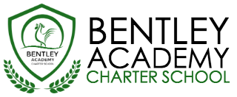
Bentley Academy Charter School
Board of Trustees Meeting
Wednesday, February 24th 2016
6:00pm
At the Bentley School
25 Memorial Drive, Salem MA 01970

Mission: Bentley Academy Charter School prepares all of its students for personal and academic success to get to and through college. Through a combination of high academic standards, data-derived instructional methods, and community supports and partnerships, Bentley Academy Charter School establishes the critical foundation necessary for students to thrive as they advance in their academic careers.

6:00 | - Call to Order
6:00-6:05 | - Approval of Minutes (Action Required)
6:05-6:10 | - Budget Update
6:10-6:15 | - Head of School Report
6:15-6:30 | - Academic Report
6:45-7:30 | - 16-17 SY Staffing Organization (Action Required)
7:30 | - Adjourn  - Next Meetings: 3.23, 4.27, 5.25, 6.22, 8.24

