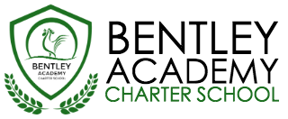
Bentley Academy Charter School
Board of Trustees Meeting
Wednesday, May 30, 2018
6:00pm
Bentley Academy Charter School
25 Memorial Drive, Salem MA 01970

Mission: Bentley Academy Charter School prepares all of its students for personal and academic success to get to and through college. Through a combination of high academic standards, data-derived instructional methods, and community supports and partnerships, Bentley Academy Charter School establishes the critical foundation necessary for students to thrive as they advance in their academic careers.

6:00 | - Call to Order
6:00-6:05 | - Approval of Minutes (Action Required)
6:05-6:30 | - Communications Consultant Search  Special Guests: Jennifer Flagg and Shelby Hypes
6:30-7:00 | - Head of School Update and Academic Update
7:00-7:15 | - Finance Update
7:15-7:35 | - New Trustee Search  - Special Guest: Alyce Davis
7:35-7:50 | - Head of School Evaluation Update
7:50-8:00 | - Committee Updates  - New Business
8:00 | - Adjourn (Action Required)

- Next meetings:
  - June 27
  - August 29

