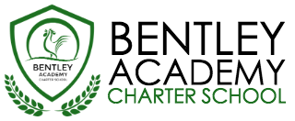
Bentley Academy Charter School
Board of Trustees Meeting
Wednesday, October 25, 2017
6:00pm
Bentley Academy Charter School
25 Memorial Drive, Salem MA 01970

Mission: Bentley Academy Charter School prepares all of its students for personal and academic success to get to and through college. Through a combination of high academic standards, data-derived instructional methods, and community supports and partnerships, Bentley Academy Charter School establishes the critical foundation necessary for students to thrive as they advance in their academic careers.

6:00 | - Call to Order
6:00-6:05 | - Approval of Minutes (Action Required)
6:05-6:30 | - Finance and Auditors Report
6:30-7:00 | - Partner for Site Visits  - Special Guest: Alyce Davis, Ed.D.
7:00-7:45 | - Head of School Update and Academic Update
7:45-8:00 | - Committee Updates  - Strategic Planning Update
8:00 | - Adjourn (Action Required)

- Next Meetings: 11/29, December – TBD/no meeting

