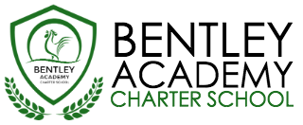
Bentley Academy Charter School
Board of Trustees Meeting
Wednesday, February 15, 2017
6:00pm
At the Bentley School
25 Memorial Drive, Salem MA 01970

Mission: Bentley Academy Charter School prepares all of its students for personal and academic success to get to and through college. Through a combination of high academic standards, data-derived instructional methods, and community supports and partnerships, Bentley Academy Charter School establishes the critical foundation necessary for students to thrive as they advance in their academic careers.

6:00 | - Call to Order
6:00-6:05 | - Approval of Minutes (Action Required)
6:05-6:30 | - Special Guest: Jennifer Flagg – Communications Plan Update
6:30-7:00 | - Head of School Update and Academic Update  - Special Guest:
7:00-7:15 | - Finance Update
7:15-7:45 | - New Trustee Search
8:00 | - Adjourn  - Next meeting: 3/15/17

