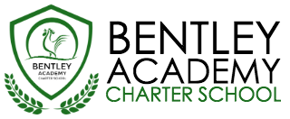
Bentley Academy Charter School
Board of Trustees Meeting
Wednesday, May 4th 2016
6:00pm
At the Bentley School
25 Memorial Drive, Salem MA 01970

Mission: Bentley Academy Charter School prepares all of its students for personal and academic success to get to and through college. Through a combination of high academic standards, data-derived instructional methods, and community supports and partnerships, Bentley Academy Charter School establishes the critical foundation necessary for students to thrive as they advance in their academic careers.

6:00 | - Call to Order
6:00-6:05 | - Approval of Minutes (Action Required)
6:05-6:10 | - Questions on Academic Update and Head of School Update
6:10-6:15 | - Finance Update
6:15-7:15 | - Report and Recommendation on Head of School Search – Executive Session
7:15-7:25 | - Head of School Selection (Action Required)
7:25-7:40 | - Committee Updates
7:40 | - Adjourn  - Next Meetings: 5.25, 6.22, 8.24

