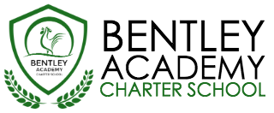
Bentley Academy Charter School
Board of Trustees Meeting
Wednesday, March 28, 2018
6:00pm
Bentley Academy Charter School
25 Memorial Drive, Salem MA 01970

Mission: Bentley Academy Charter School prepares all of its students for personal and academic success to get to and through college. Through a combination of high academic standards, data-derived instructional methods, and community supports and partnerships, Bentley Academy Charter School establishes the critical foundation necessary for students to thrive as they advance in their academic careers.

6:00 | - Call to Order
6:00-6:05 | - Approval of Minutes (Action Required)
6:05-6:30 | - Head of School Update and Academic Update
6:30-6:45 | - Financial Update and Budget
6:45-7:15 | - Update on search for Communications Consultant
7:15-7:30 | - Update on electronic document storage
7:30-7:45 | - Calendar planning for next academic year
7:45-8:00 | - Committee Updates  - New Business
8:00 | - Adjourn (Action Required)

- March 28, 2018
- April 25, 2018
- May 30, 2018

